About BLUETICKGENG DEVELOPMENT

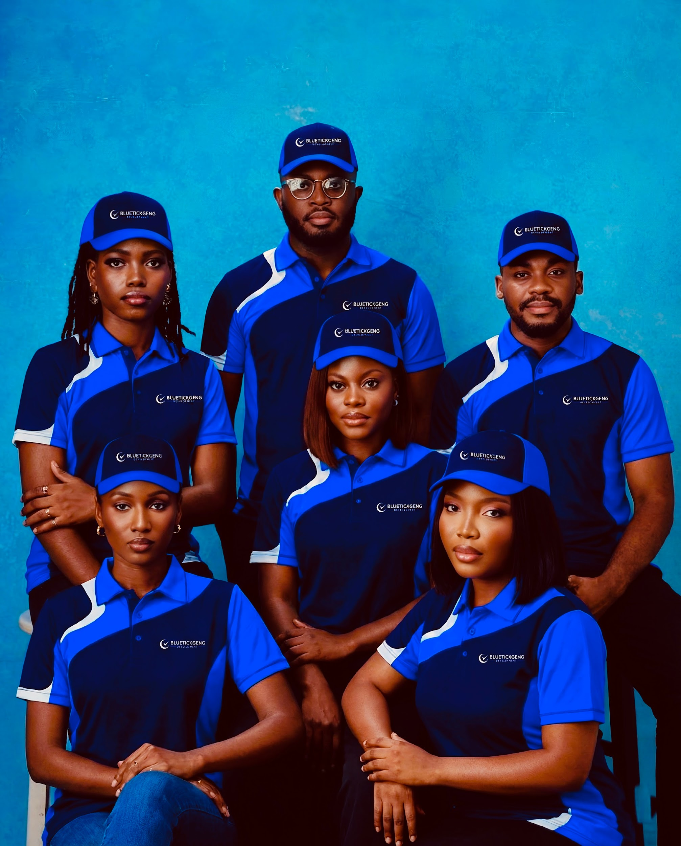
Bluetickgeng Development is an international technology and digital solutions company providing end-to-end services in mobile application development for iOS and Android, website and web application development, e-commerce solutions, digital marketing, branding, and online reputation management. With operations spanning Africa and the United States, the company serves a diverse global client base across multiple industries.
The company also offers specialized services including social media account verification, Wikipedia page creation and management, Google Knowledge Panel development, news and media publishing, public relations distribution, social media management, graphic design, user interface and user experience design, content creation, and business growth consulting. By combining software engineering with digital visibility and media strategies, BLUETICKGENG DEVELOPMENT enables businesses, entrepreneurs, creators, and public figures to build scalable digital products while strengthening their online credibility, authority, and search presence.
Founded in 2023 by entrepreneur and technology innovator Praise Davis, BLUETICKGENG DEVELOPMENT was established with a vision to bridge the gap between technology, branding, media exposure, and digital credibility. Since its inception, the company has grown from a software development startup into a multidisciplinary digital solutions provider serving clients across multiple industries and international markets. (Wikipedia)
We believe that modern businesses need more than just a website or social media presence. They need powerful technology, strategic branding, media visibility, digital authority, and scalable growth systems. This philosophy has enabled us to become a trusted partner for startups, established businesses, public figures, influencers, and organizations seeking sustainable digital growth

What We Do
BLUETICKGENG DEVELOPMENT provides a comprehensive suite of technology and digital growth services designed to help clients launch, grow, and scale successfully.
Our services include:

Technology Solutions
• Mobile App Development (iOS & Android)
• Custom Software Development
• Website Design & Development
• Fintech & Digital Banking Solutions
• E-commerce Platforms
• Business Automation Systems
• UI/UX Design

Digital Visibility & Authority
• Social Media Verification Services
• Wikipedia Page Creation & Management
• Google Knowledge Panel Development
• Online Reputation Management
• Digital Identity Solutions

Branding & Marketing
• Brand Strategy Development
• Corporate Branding
• Logo & Identity Design
• Social Media Growth
• Digital Marketing Campaigns
• Content Marketing

Public Relations & Media
• Press Release Distribution
• Digital Newspaper Publications
• Media Visibility Campaigns
• Public Relations Consulting
• Strategic Brand Positioning

Innovation Beyond Technology
At BLUETICKGENG DEVELOPMENT, we understand that visibility and credibility are just as important as technology. This understanding inspired our approach to combining software development with public relations, media exposure, and digital branding services.
Through innovative digital solutions, we have helped businesses, startups, creators, and organizations gain access to media visibility opportunities that were traditionally difficult or expensive to obtain. Our integrated model combines technology, branding, and media to create measurable business impact. (Businessday NG)

Industry Recognition
Our commitment to innovation and digital transformation has earned recognition across the technology industry.
BLUETICKGENG DEVELOPMENT was recognized as Tech Innovator of the Year at the Yessiey Awards for its contributions to digital transformation and technology-driven business solutions. The company has also been featured by major media platforms including BusinessDay, The Punch, Vanguard, ThisDay, Independent, Tribune, PM News, GhanaWeb, and New Telegraph for its work in technology, innovation, digital transformation, public relations, and software development. (Wikipedia)

Global Expansion

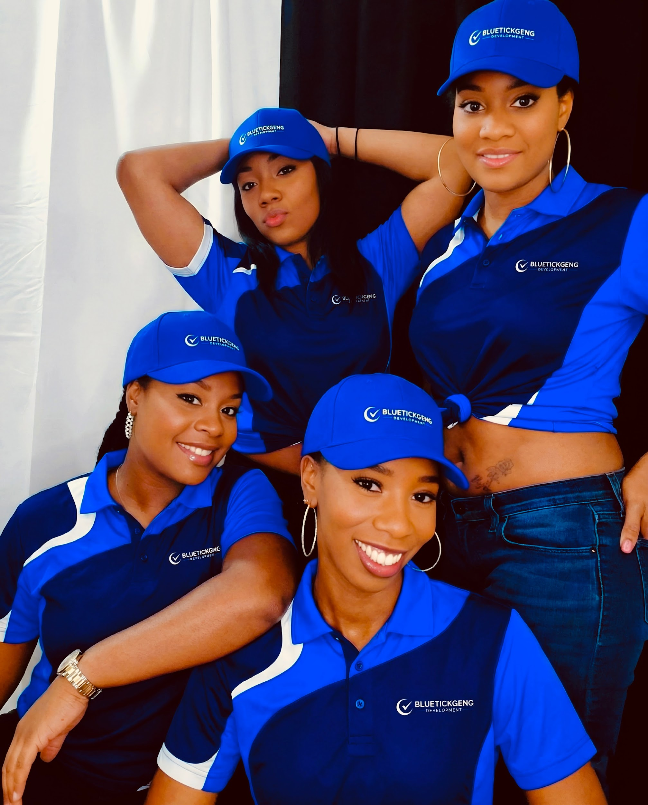
In 2025, BLUETICKGENG DEVELOPMENT expanded its operations into the United States, marking a significant milestone in the company’s growth journey. The expansion was designed to strengthen international service delivery, support global clients, and create new opportunities for businesses seeking technology and digital growth solutions beyond geographical boundaries. (GhanaWeb)
Today, the company operates with a growing international outlook while maintaining its commitment to delivering world-class solutions from its Nigerian roots.

Our Mission
To empower businesses, brands, and individuals with innovative technology, strategic media visibility, and digital growth solutions that create lasting impact and measurable success.

Our Vision
To become one of Africa’s most influential technology and digital growth companies, helping businesses and individuals compete successfully on a global scale through innovation, visibility, and digital transformation.

Why Choose BLUETICKGENG DEVELOPMENT?
We don’t simply build websites or mobile apps.
We build brands.
We create visibility.
We establish credibility.
We develop technology that solves real-world problems.
Whether you’re launching a startup, growing an established business, building a personal brand, seeking media exposure, obtaining social media verification, creating a Wikipedia page, or developing a custom software solution, BLUETICKGENG DEVELOPMENT provides the expertise, innovation, and strategic support needed to achieve your goals.
As we continue expanding globally, our focus remains unchanged: helping businesses and individuals leverage technology, branding, and media to unlock their full potential.


Website: www.bluetickgeng.com
Email: info@bluetickgeng.com
WhatsApp: +234 913 883 2111

